TUTORIAL 4 ANSWERS

1. What are the main data structures necessary for an assembly scheme? State the purpose of each of them.

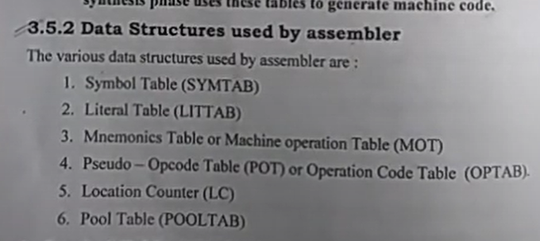

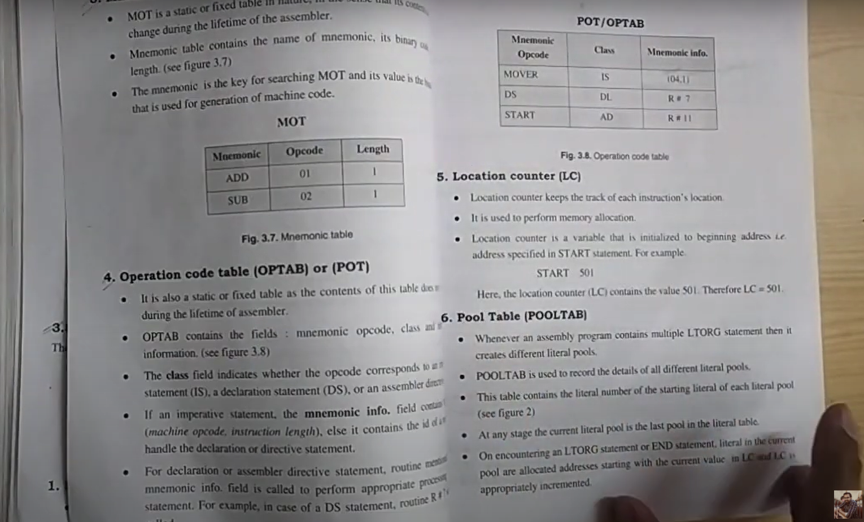

<https://youtu.be/cNJZ8eNo8UA>

The basic data structure used in assembler is**the Operation Code table (OPTAB) and the Symbol Table (SYMTAB).**

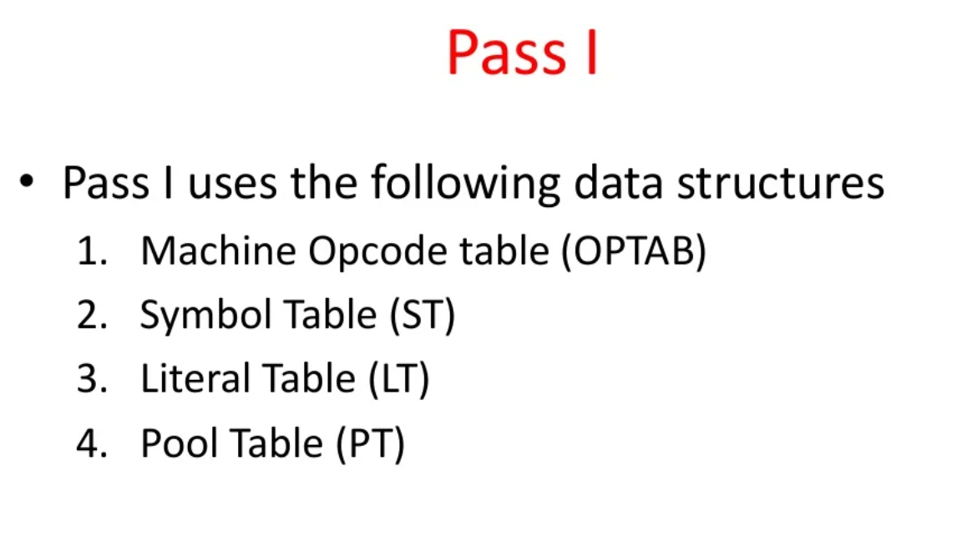

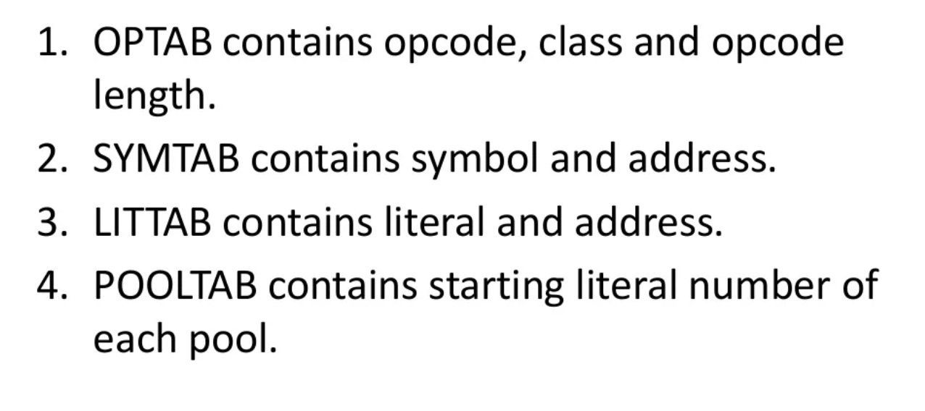

2. Write down the pass numbers(PASS 1/ PASS 2) of the following activities that occur in a two pass assembler:

a. Object code generation

b. Literals added to literal table

c. Listing printed

d. Address location of local symbols

ANSWER - 2,1,2,1

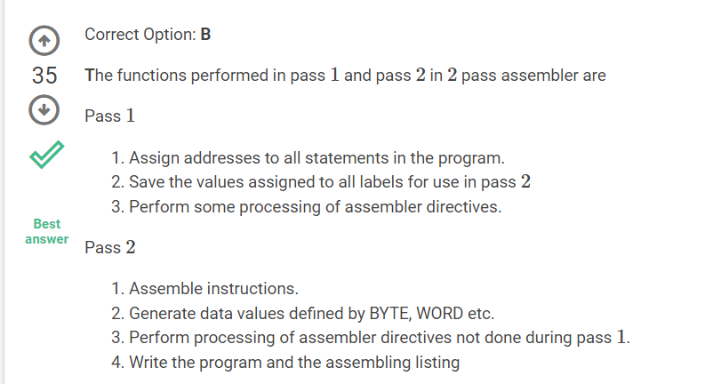

<https://gateoverflow.in/2721/Gate-cse-1996-question-1-17>

3. Explain the concept of single pass assembler with a suitable example.

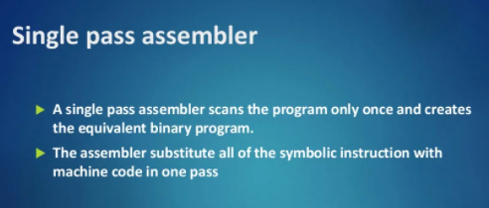

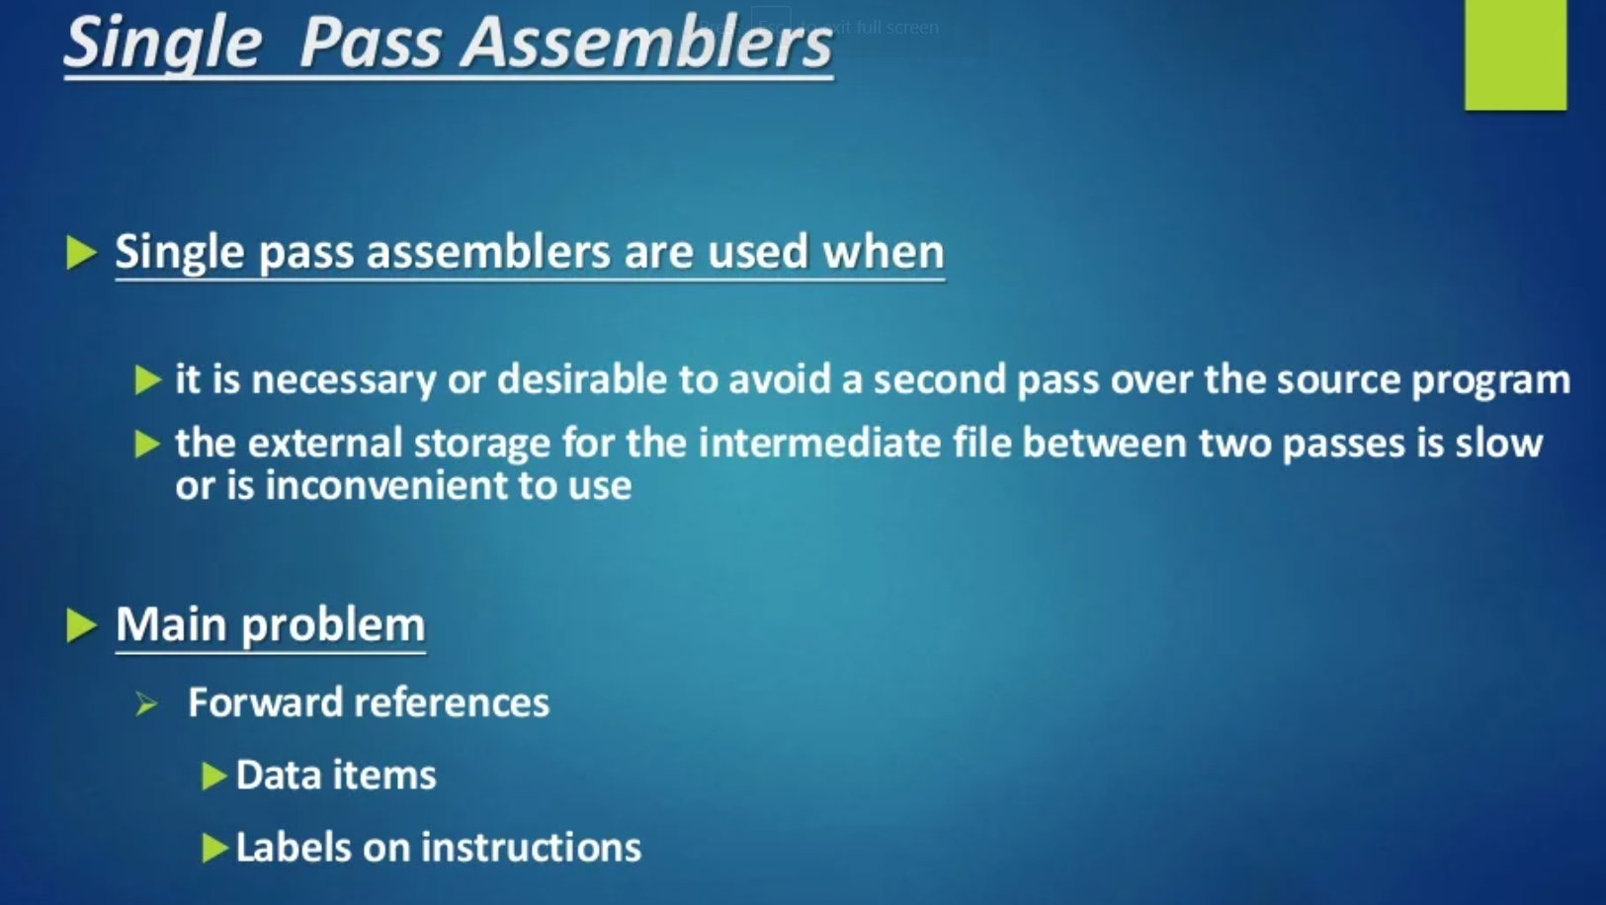

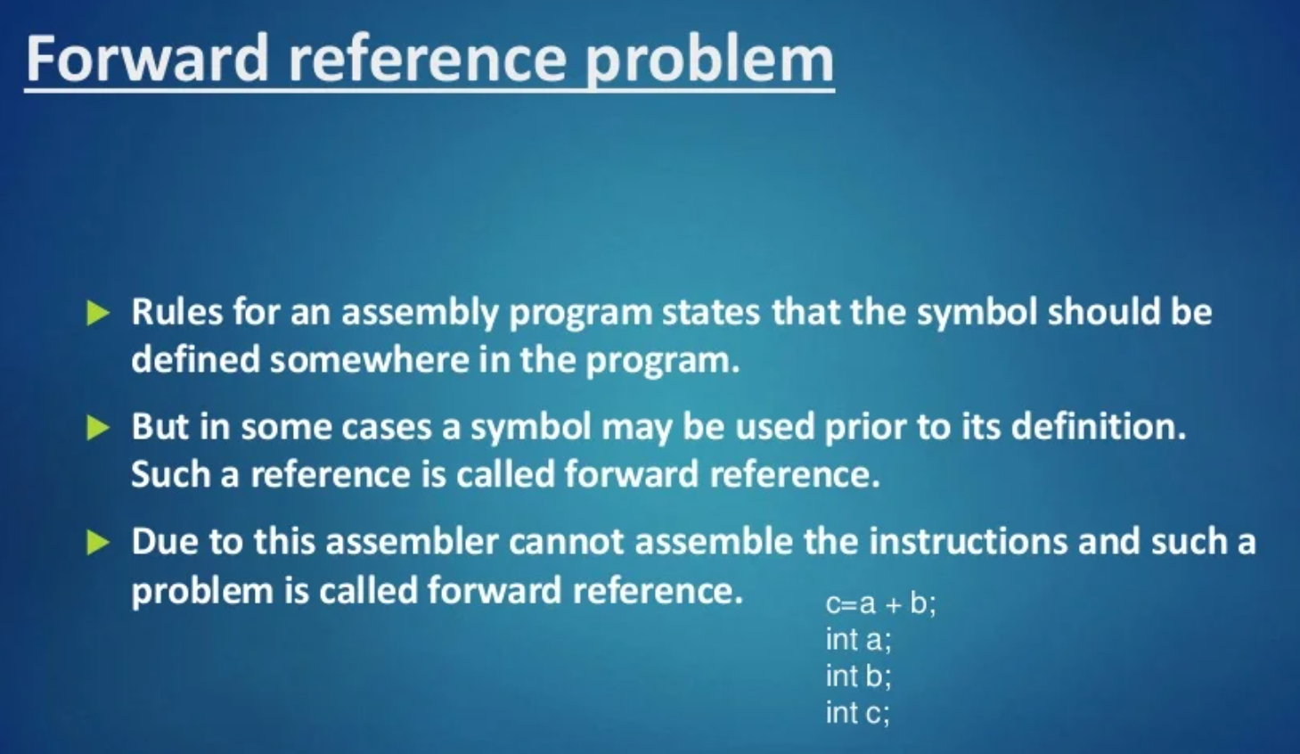

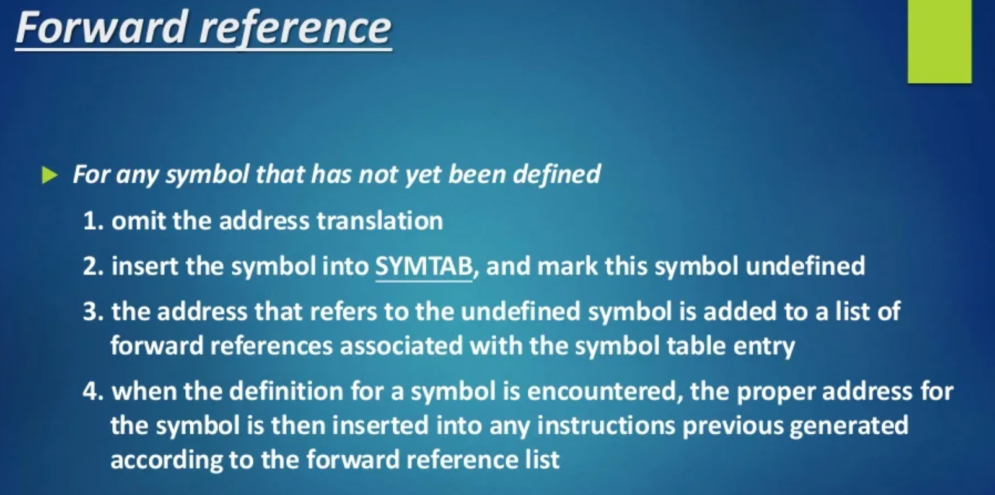

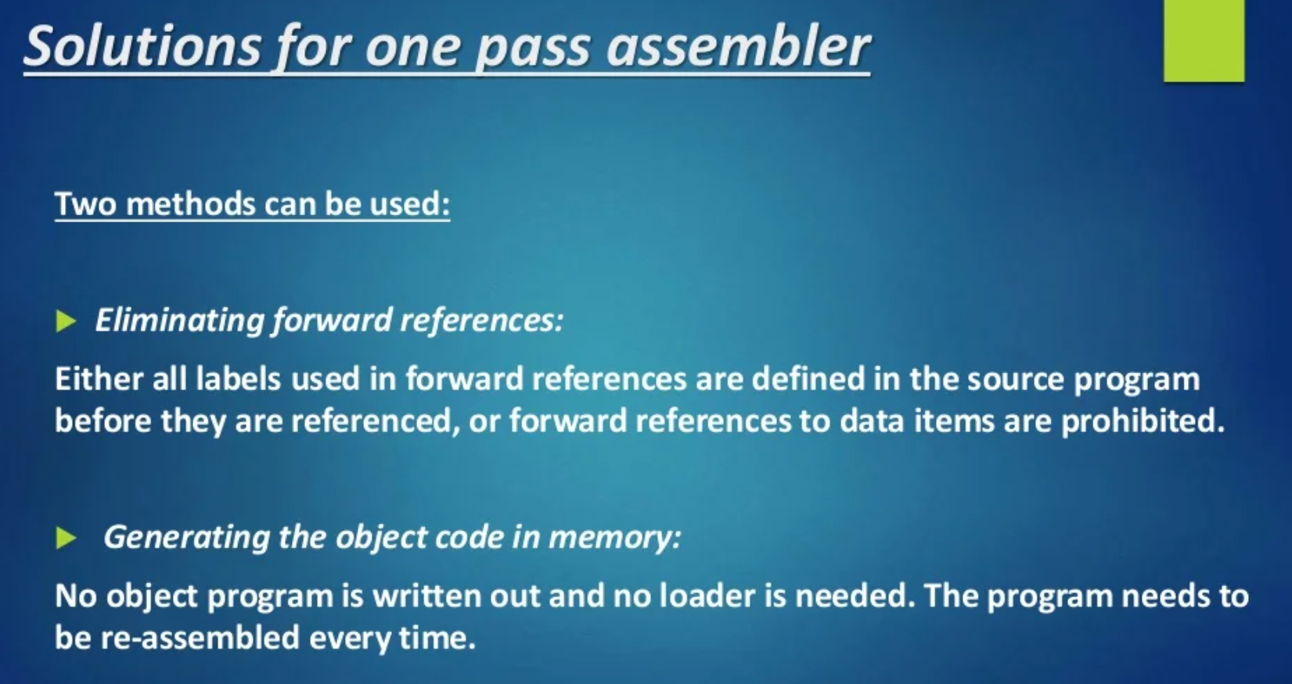

<https://youtu.be/DUaO8XT6SRo>

4. Given the following source program:

Show the content of the symbol table, MOT at the end of PASS 1.

START 102

READ X

READ Y

MOVER AREG, X

ADD AREG, Y

MOVEM AREG, RESULT

PRINT RESULT

STOP

X DS 1

Y DS 1

RESULT DS 1

END

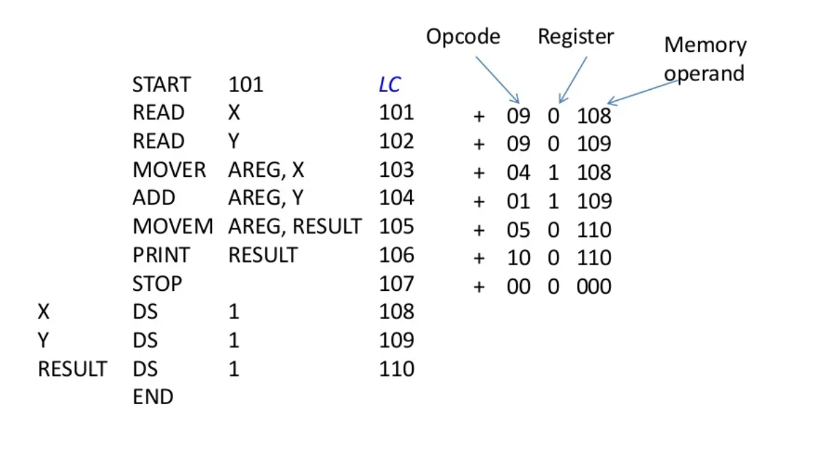

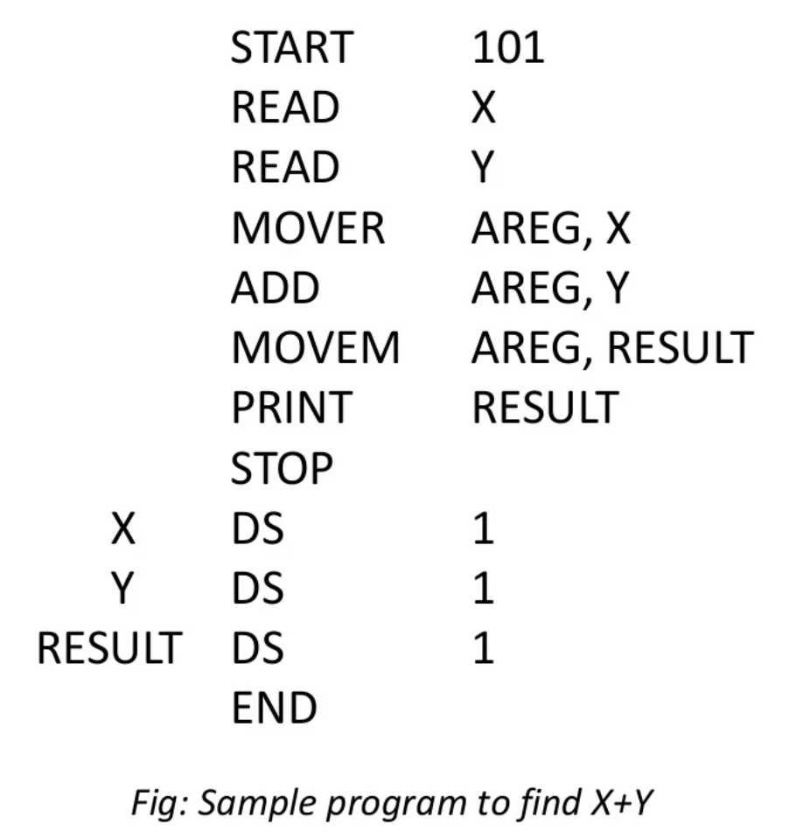

5. Design an automata for valid identifiers, integer constant and comments.

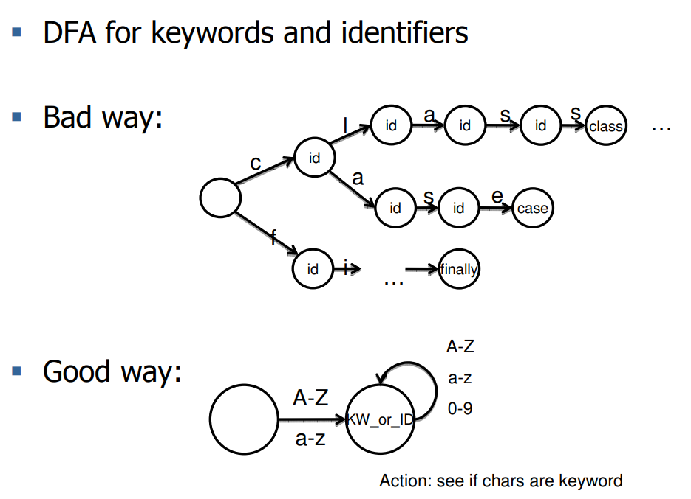

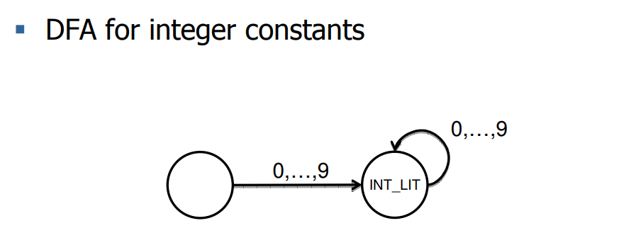

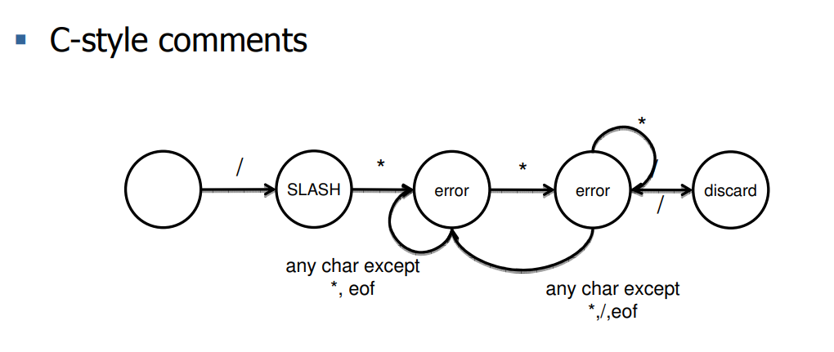

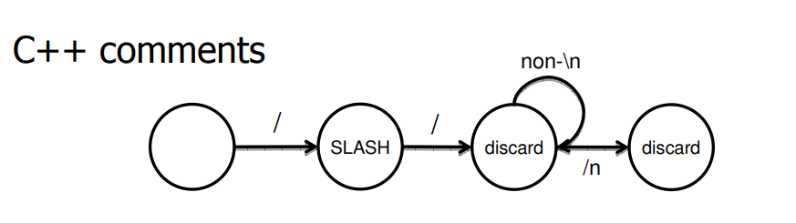

6. Design an automata which accept a language of all strings starting with ‘a’ and ending with ‘b.’

